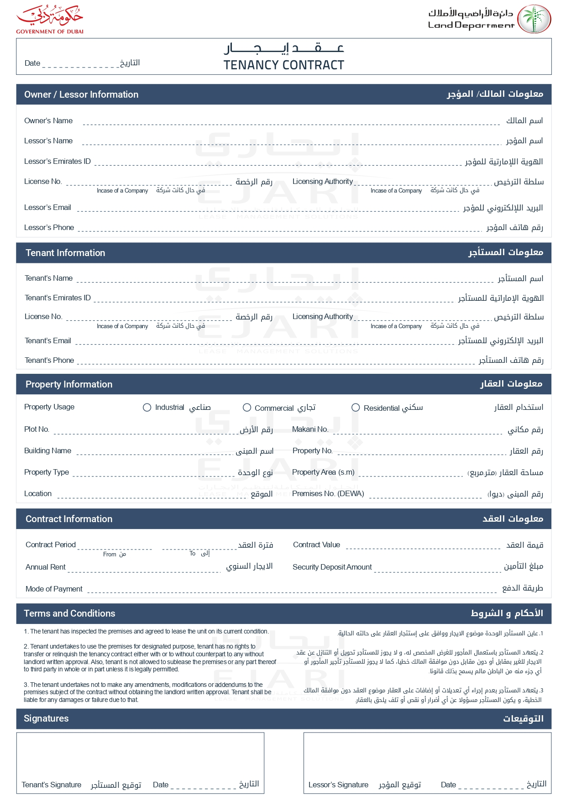

2025-04-09

John Smith

John Smith

john.smith@example.com

+971501234567

David Wilson

david.w@example.com

+971504567890

✓

G-101

Green Villa

1,400.00

GV001

2,000.00 EGP

2025-08-09

2025-04-09

100.00 EGP

2,000.00 EGP

Weekly

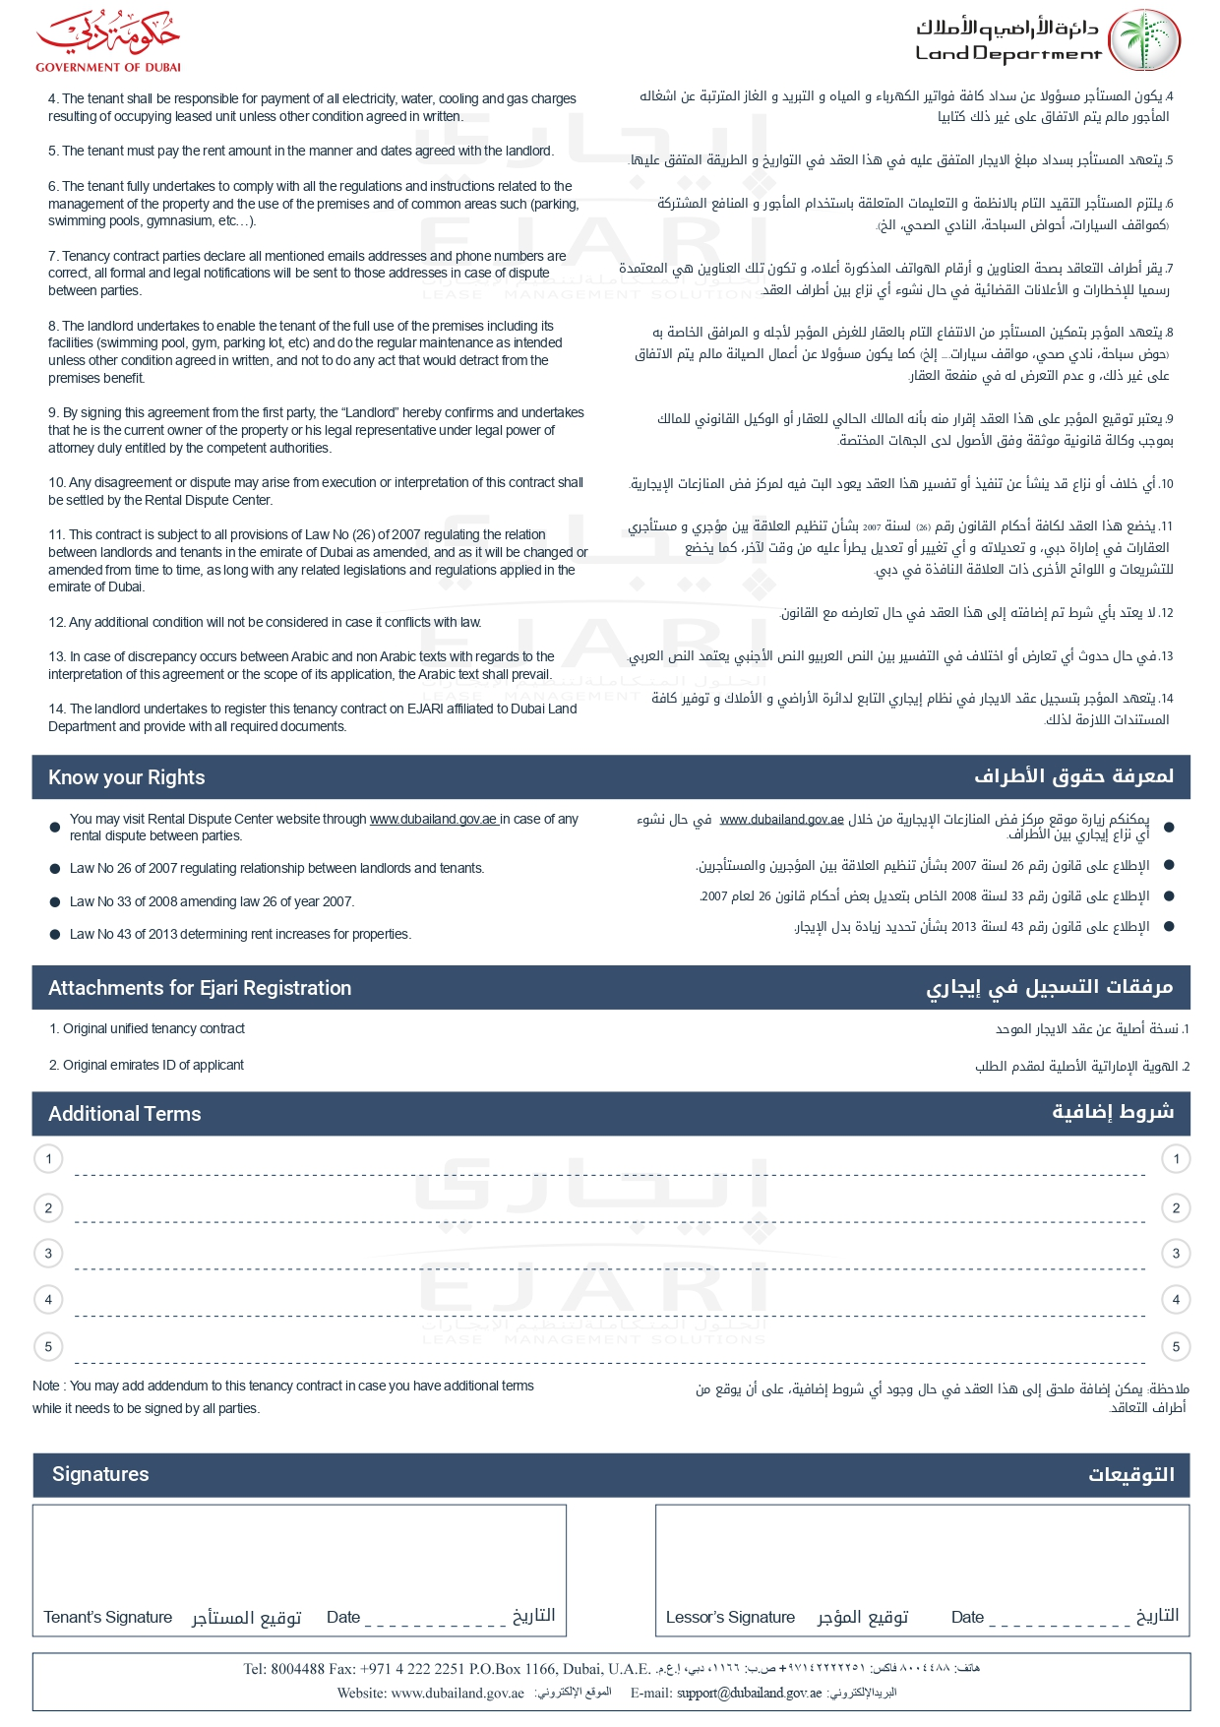

string terms 1